Leonard M, Hochstein, MD

585 NW 161st Street, Miami, FL 33169 | (305) 931-3338

**JP Drain Care**

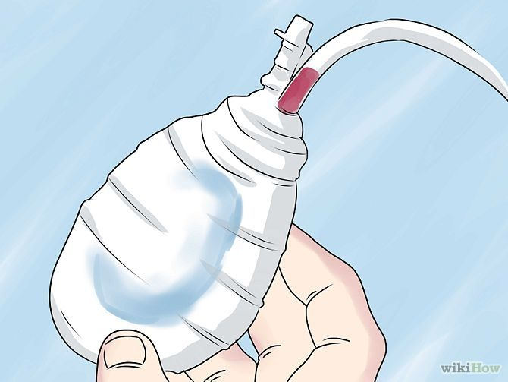You have been discharged with a Jackson Pratt Closed Suction System, better known as a JP drain. The flat perforated end of the tube is placed inside your body so that it can collect the body fluid that is produced as an effect from surgery.

Serous fluid and blood mixed together is called serosanguinous fluid. The drain is designed to collect the serosanguinous fluid by way of suction. The drain helps to reduce the risk of infection and seroma, which is a build-up of fluid in the soft tissues.

**How to Care for your drain at home**

• Clean the area around the drain at least once per day.

Remove any dressing from around the drain. Use soap and water to clean the drain site and the skin around it.

• It is okay to shower with your drains in place. Please do not take a bath or submerge your drains.

Make sure to secure drains to something around your neck or hold the drain in your hand so the drain is not hanging from the sutures and your body.

**How to Empty your drain**

• Wash your hands.

• Strip tubing three times a day (more often if there are a lot of blood clots.)

* + - * Grasp tubing close to body with one hand and hold toward body, as not to pull on sutures. With other hand grasp tubing below the first hand. Pinch tubing tightly, sliding fingers down tubing, away from your body.
      * Repeat 2 or 3 times. Be sure drainage is flowing into bulb.

• Pull the plug out of the bulb

• Pour the fluid from the bulb into a cup

• Squeeze the bulb flat. While the bulb is flat, put the plug back into the bulb. The bulb should stay flat after it is plugged so that the vacuum suction can restart.

• Write the amount of drainage, along with the date and time you collected it, on the JP drainage chart at the end of this document.

• Discard fluid in the toilet

**Call us at (305) 931-3338 or email your coordinator if you have any questions.**